Lab 4 – Projectile Motion
Video URL link: https://www.youtube.com/watch?v=BriazLkgXa4&list=PLLF2jNBy_OPumuv2eSvIbvnDDfQj0cGEU&index=2
All entries should have base SI units
Show all calculation steps
In-person Instructions
- Level the apparatus with bubble level
- Move apparatus so it is flush with the table’s edge
- Measure dimension data
- Record data for 10 trials
- Number each trial on the impact sheet
  - Take a picture and include in the submitted assignment
- Record data for 10 trials
- Report the initial velocity with appropriate uncertainty

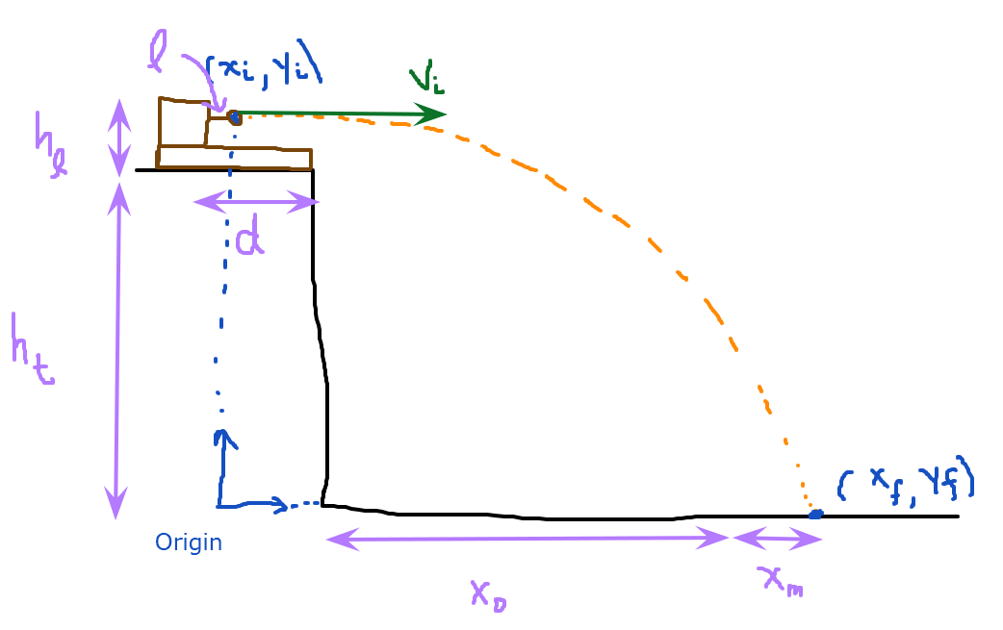

Length of launcher $(l)$ | 7.1 cm
Distance to edge of table $(d)$ | 34.2 cm
Table and platform height $(h_{t})$ | 80.5 cm
Launcher height $(h_{l})$ | 7.5 cm
Paper position $(x_{0})$ | 175.1 cm

Initial position $(x_{i})$ | 0
Initial vertical position $(y_{i}=h_{t}+h_{l})$ | 88 cm
Final vertical position $(y_{f})$ | 0
Initial vertical velocity $(v_{iy})$ | 0 ? not sure

Trial number | Measured data  $$x_{m}$$ | Calculated column  $$x_{f}=\left(d-l\right)+x_{0}+x_{m}$$
1 | 11.3 cm | 213.5cm
2 | 12.2 cm | 214.4cm
3 | 12.7 cm | 214.9cm
4 | 13 cm | 215.2cm
5 | 14.4 cm | 216.6cm
6 | 13.2 cm | 215.4cm
7 | 14.7 cm | 216.9cm
8 | 11.3 cm | 213.5cm
9 | 9.6 cm | 211.8cm
10 | 10.4 cm | 212.6cm

If you are in-person, copy a photo of your impact sheet here (with each trial number labeled)

In calculating the mean and standard deviation I used scientific calculator.

Mean of x_{f} | Standard Deviation | 2σ
214.5cm | 1.60 | 2.40

Derive an equation to predict initial velocity in terms of measured quantities $x_{f}$, $g=-9.8\frac{m}{s^{2}}$, and $y_{i}$ by plugging in known initial/final conditions and combining the following two equations:
$$x_{f}=v_{ix}t+x_{i}$$
$$y_{f}=\frac{1}{2}gt^{2}+v_{iy}t+y_{i}$$

solution
The horizontal and vertical components are interdependent of each other. But we know that xi and yi are 0 as from our results.
So our equations become
$$x_{f}=v_{ix}t$$

$${}_{f}=\frac{1}{2}gt^{2}+v_{iy}t$$
So our initial velocity become the sum of the two equations
making vertical and horizontal velocities subject of the formula in both cases it becomes
vix=xf/t
- Viy=1/2gt-yf/t
Adding the two we get
Initial velocity=Xf/t+-1/2gt-Yf/t

Yf being zero our equation becomes
Xf/t-1/2gt the time in the equations will counsel out
Our equation will be Xf-1/2g=initial velocity

OUR initial velocity is going to become
214.5/100-1/2*9.8
214.5/100-0.051=2.094m/s
Our initial velocity is 2.094m/s

By applying the method of adding percent uncertainty you would get the following equation. Note that$δx_{m}=2σ$ from above and $δy=0.001 m$.
$$\frac{δv_{i}}{v_{i}}=\frac{1}{2}\left(2\frac{δx_{f}}{x_{f}}+\frac{δy}{y}\right)$$
$$uncertainty of initial velocity=\frac{1}{2}\left(2\frac{δx_{f}}{x_{f}}+\frac{δy}{y}\right)vi$$

½(2*2.40/214.5 + 0.001/88)*2.094=0.0230
Report your initial velocity in the form $v_{i}±δv_{i}$.
Initial velocity | $2.094±0.0230m/s$.

